Practical 1

* + Implementation of SDES algorithm in C language.

Keygen.h

*// HEADER FILE FOR KEY GENERATION*

*#include* <stdio.h>

*#include* <math.h>

*#include* <string.h>

*void* permuteKey(*char* key*[]*, *char* permutedKey*[]*)

{

*int* i;

*int* permutationTable[10] = {3, 5, 2, 7, 4, 10, 1, 9, 8, 6};

*for* (i = 0; i < 10; i++)

    {

        permutedKey[i] = key[permutationTable[i] - 1];

    }

}

*void* generateLeftRightKey(*char* key*[]*, *char* leftKey*[]*, *char* rightKey*[]*)

{

*int* i;

*for* (i = 0; i < 5; i++)

    {

        leftKey[i] = key[i];

    }

*for* (i = 5; i < 10; i++)

    {

        rightKey[i - 5] = key[i];

    }

}

*void* leftShift(*char* key*[]*, *int* shift)

{

*int* i;

*char* tempKey[5];

    strcpy(tempKey, key);

*for* (i = 0; i < 5; i++)

    {

        key[i] = tempKey[(i + shift) % 5];

    }

}

*void* p8(*char* key*[]*, *char* key1*[]*)

{

*int* i;

*int* permutationTable[8] = {6, 3, 7, 4, 8, 5, 10, 9};

*for* (i = 0; i < 8; i++)

    {

        key1[i] = key[permutationTable[i] - 1];

    }

    key1[i] = '\0';

}

*void* generateKey1(*char* leftKey*[]*, *char* rightKey*[]*, *char* key1*[]*)

{

*int* i;

*char* tempKey[10];

    leftShift(leftKey, 1);

    leftShift(rightKey, 1);

*for* (i = 0; i < 5; i++)

    {

        tempKey[i] = leftKey[i];

    }

*for* (i = 5; i < 10; i++)

    {

        tempKey[i] = rightKey[i - 5];

    }

    p8(tempKey, key1);

}

*void* generateKey2(*char* leftKey*[]*, *char* rightKey*[]*, *char* key2*[]*)

{

*int* i;

*char* tempKey[10];

    leftShift(leftKey, 2);

    leftShift(rightKey, 2);

*for* (i = 0; i < 5; i++)

    {

        tempKey[i] = leftKey[i];

    }

*for* (i = 5; i < 10; i++)

    {

        tempKey[i] = rightKey[i - 5];

    }

    p8(tempKey, key2);

}

*void* generateKeys(*char* key*[]*, *char* key1*[]*, *char* key2*[]*)

{

*char* leftKey[5], rightKey[5], permutedKey[10];

    permuteKey(key, permutedKey);

    generateLeftRightKey(permutedKey, leftKey, rightKey);

    generateKey1(leftKey, rightKey, key1);

    generateKey2(leftKey, rightKey, key2);

}

Encrypt.h

*// HEADER FILE FOR ENCRYPTION*

*#include* <stdio.h>

*#include* <math.h>

*#include* <string.h>

*void* charToBinary(*char* input, *char* *output)

{

*int* i;

*if* (input == 0) {

*for* (i = 0; i < 8; i++)

        {

            output[i] = '0';

        }

    }

*else* {

*for* (i = 8; i > 0; i--)

        {

*if* (input % 2 == 0)

            {

                output[i - 1] = '0';

            }

*else*

            {

                output[i - 1] = '1';

            }

            input = input / 2;

        }

    }

    output[8] = '\0';

}

*void* binaryToChar(*char* *input, *char* *output)

{

*int* i;

    *output = 0;

*for* (i = 0; i < 8; i++)

    {

        *output = *output + (input[i] - '0') * pow(2, 7 - i);

    }

}

*void* ip8(*char* *input, *char* *output)

{

*int* i;

*int* ip*[]* = {2, 6, 3, 1, 4, 8, 5, 7};

*for* (i = 0; i < 8; i++)

    {

        output[i] = input[ip[i] - 1];

    }

    output[8] = '\0';

}

*void* devide(*char* *input, *char* *left, *char* *right)

{

*int* i;

*for* (i = 0; i < 4; i++)

    {

        left[i] = input[i];

        right[i] = input[i + 4];

    }

    left[4] = '\0';

    right[4] = '\0';

}

*void* ep(*char* *input, *char* *output)

{

*int* i;

*int* ep*[]* = {4, 1, 2, 3, 2, 3, 4, 1};

*for* (i = 0; i < 8; i++)

    {

        output[i] = input[ep[i] - 1];

    }

    output[8] = '\0';

}

*void* xor8bit(*char* *input1, *char* *input2, *char* *output)

{

*int* i;

*for* (i = 0; i < 8; i++)

    {

        output[i] = (input1[i] - '0') ^ (input2[i] - '0') + '0';

    }

    output[8] = '\0';

}

*void* sBox(*char* *input, *char* *output)

{

*int* s0[4][4] = {{1, 0, 3, 2},

                    {3, 2, 1, 0},

                    {0, 2, 1, 3},

                    {3, 1, 3, 2}};

*int* s1[4][4] = {{0, 1, 2, 3},

                    {2, 0, 1, 3},

                    {3, 0, 1, 0},

                    {2, 1, 0, 3}};

*int* i = (input[0] - '0') * 2 + (input[3] - '0');

*int* j = (input[1] - '0') * 2 + (input[2] - '0');

*int* k = (input[4] - '0') * 2 + (input[7] - '0');

*int* l = (input[5] - '0') * 2 + (input[6] - '0');

    output[0] = s0[i][j] / 2 + '0';

    output[1] = s0[i][j] % 2 + '0';

    output[2] = s1[k][l] / 2 + '0';

    output[3] = s1[k][l] % 2 + '0';

    output[4] = '\0';

}

*void* p4(*char* *input, *char* *output)

{

*int* i;

*int* p*[]* = {2, 4, 3, 1};

*for* (i = 0; i < 4; i++)

    {

        output[i] = input[p[i] - 1];

    }

    output[4] = '\0';

}

*void* xor4bit(*char* *input1, *char* *input2, *char* *output)

{

*int* i;

*for* (i = 0; i < 4; i++)

    {

        output[i] = (input1[i] - '0') ^ (input2[i] - '0') + '0';

    }

    output[4] = '\0';

}

*void* combine(*char* *input1, *char* *input2, *char* *output)

{

*int* i;

*for* (i = 0; i < 4; i++)

    {

        output[i] = input1[i];

        output[i + 4] = input2[i];

    }

    output[8] = '\0';

}

*void* swap(*char* *input, *char* *output)

{

*int* i;

*char* temp;

*for* (i = 0; i < 4; i++)

    {

        temp = input[i];

        input[i] = output[i];

        output[i] = temp;

    }

    output[4] = '\0';

}

*void* ip8Inverse(*char* *input, *char* *output)

{

*int* i;

*int* ip*[]* = {4, 1, 3, 5, 7, 2, 8, 6};

*for* (i = 0; i < 8; i++)

    {

        output[i] = input[ip[i] - 1];

    }

    output[8] = '\0';

}

*void* encryptForK(*char* *bin, *char* *key, *char* *output)

{

*// Step 2: IP8*

*char* ip8Output[9];

    ip8(bin, ip8Output);

*// Step 3: Devide 4n4*

*char* ip8Left[5], ip8Right[5];

    devide(ip8Output, ip8Left, ip8Right);

*// Step 4: EP*

*char* epOutput[9];

    ep(ip8Right, epOutput);

*// Step 5: XOR 8-bit*

*char* xorOutput[9];

    xor8bit(epOutput, key, xorOutput);

*// Step 6 and 7: S-Box*

*char* sBoxOutput[5];

    sBox(xorOutput, sBoxOutput);

*// Step 8: P4*

*char* p4Output[5];

    p4(sBoxOutput, p4Output);

*// Step 9:*

*char* xorOutput2[5];

    xor4bit(p4Output, ip8Right, xorOutput2);

*// Step 10: Combine S3*

*char* combineOutput[9];

    combine(ip8Left, xorOutput2, combineOutput);

*// Step 11: Devide 4n4*

*char* combineLeft[5], combineRight[5];

    devide(combineOutput, combineLeft, combineRight);

*// Step 12: Swap*

    swap(combineLeft, combineRight);

*// Step 13: Combine step 12 and generate output*

*char* combineOutput2[9];

    combine(combineLeft, combineRight, combineOutput2);

*// Copy the combined output to the final output*

    strcpy(output, combineOutput2);

}

*void* encrypt(*char* c, *char* *k1, *char* *k2, *char* *output)

{

*// Step 1: Char to Binary*

*char* bin[9];

    charToBinary(c, bin);

*char* output1[9], output2[9], output3[9];

    encryptForK(bin, k1, output1);

    encryptForK(output1, k2, output2);

*// Final inverse permutation*

    ip8Inverse(output2, output3);

    output3[8] = '\0';

*// Copy the final output to the provided output buffer*

    strcpy(output, output3);

}

SDES.c

*// SDES implementation in C*

*// REFERENCE: https://www.c-sharpcorner.com/article/s-des-or-simplified-data-encryption-standard/*

*#include* <stdio.h>

*#include* <string.h>

*#include* "keygen.h"

*#include* "encrypt.h"

*char* key[10];

*char* key1[9];

*char* key2[9];

*char* inputString[100];

*char* output[9];

*char* outputBits[900];

*void* main()

{

*int* i;

    printf("Enter the 10 bit key: ");

    scanf("%s", &key);

    generateKeys(key, key1, key2);

    printf("Key 1: %s\n", key1);

    printf("Key 2: %s\n", key2);

    printf("Enter input string: ");

    scanf("%s", &inputString);

*int* len = strlen(inputString);

    printf("Encrypted string: ");

*for* (i = 0; i < len; i++)

    {

        encrypt(inputString[i], key1, key2, output);

*for* (*int* j = 0; j < 8; j++)

        {

            outputBits[i * 8 + j] = output[j];

        }

    }

    printf("%s\n", outputBits);

}

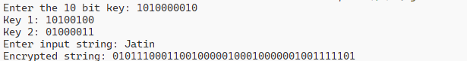OUTPUT

Practical 2

* + Application of Brute force Attack on S-DES

Keygen.h

*// HEADER FILE FOR KEY GENERATION*

*#include* <stdio.h>

*#include* <math.h>

*#include* <string.h>

*void* permuteKey(*char* key*[]*, *char* permutedKey*[]*)

{

*int* i;

*int* permutationTable[10] = {3, 5, 2, 7, 4, 10, 1, 9, 8, 6};

*for* (i = 0; i < 10; i++)

    {

        permutedKey[i] = key[permutationTable[i] - 1];

    }

}

*void* generateLeftRightKey(*char* key*[]*, *char* leftKey*[]*, *char* rightKey*[]*)

{

*int* i;

*for* (i = 0; i < 5; i++)

    {

        leftKey[i] = key[i];

    }

*for* (i = 5; i < 10; i++)

    {

        rightKey[i - 5] = key[i];

    }

}

*void* leftShift(*char* key*[]*, *int* shift)

{

*int* i;

*char* tempKey[5];

    strcpy(tempKey, key);

*for* (i = 0; i < 5; i++)

    {

        key[i] = tempKey[(i + shift) % 5];

    }

}

*void* p8(*char* key*[]*, *char* key1*[]*)

{

*int* i;

*int* permutationTable[8] = {6, 3, 7, 4, 8, 5, 10, 9};

*for* (i = 0; i < 8; i++)

    {

        key1[i] = key[permutationTable[i] - 1];

    }

    key1[i] = '\0';

}

*void* generateKey1(*char* leftKey*[]*, *char* rightKey*[]*, *char* key1*[]*)

{

*int* i;

*char* tempKey[10];

    leftShift(leftKey, 1);

    leftShift(rightKey, 1);

*for* (i = 0; i < 5; i++)

    {

        tempKey[i] = leftKey[i];

    }

*for* (i = 5; i < 10; i++)

    {

        tempKey[i] = rightKey[i - 5];

    }

    p8(tempKey, key1);

}

*void* generateKey2(*char* leftKey*[]*, *char* rightKey*[]*, *char* key2*[]*)

{

*int* i;

*char* tempKey[10];

    leftShift(leftKey, 2);

    leftShift(rightKey, 2);

*for* (i = 0; i < 5; i++)

    {

        tempKey[i] = leftKey[i];

    }

*for* (i = 5; i < 10; i++)

    {

        tempKey[i] = rightKey[i - 5];

    }

    p8(tempKey, key2);

}

*void* generateKeys(*char* key*[]*, *char* key1*[]*, *char* key2*[]*)

{

*char* leftKey[5], rightKey[5], permutedKey[10];

    permuteKey(key, permutedKey);

    generateLeftRightKey(permutedKey, leftKey, rightKey);

    generateKey1(leftKey, rightKey, key1);

    generateKey2(leftKey, rightKey, key2);

}

Encrypt.h

*// HEADER FILE FOR ENCRYPTION*

*#include* <stdio.h>

*#include* <math.h>

*#include* <string.h>

*void* charToBinary(*char* input, *char* *output)

{

*int* i;

*if* (input == 0) {

*for* (i = 0; i < 8; i++)

        {

            output[i] = '0';

        }

    }

*else* {

*for* (i = 8; i > 0; i--)

        {

*if* (input % 2 == 0)

            {

                output[i - 1] = '0';

            }

*else*

            {

                output[i - 1] = '1';

            }

            input = input / 2;

        }

    }

    output[8] = '\0';

}

*void* binaryToChar(*char* *input, *char* *output)

{

*int* i;

    *output = 0;

*for* (i = 0; i < 8; i++)

    {

        *output = *output + (input[i] - '0') * pow(2, 7 - i);

    }

}

*void* ip8(*char* *input, *char* *output)

{

*int* i;

*int* ip*[]* = {2, 6, 3, 1, 4, 8, 5, 7};

*for* (i = 0; i < 8; i++)

    {

        output[i] = input[ip[i] - 1];

    }

    output[8] = '\0';

}

*void* devide(*char* *input, *char* *left, *char* *right)

{

*int* i;

*for* (i = 0; i < 4; i++)

    {

        left[i] = input[i];

        right[i] = input[i + 4];

    }

    left[4] = '\0';

    right[4] = '\0';

}

*void* ep(*char* *input, *char* *output)

{

*int* i;

*int* ep*[]* = {4, 1, 2, 3, 2, 3, 4, 1};

*for* (i = 0; i < 8; i++)

    {

        output[i] = input[ep[i] - 1];

    }

    output[8] = '\0';

}

*void* xor8bit(*char* *input1, *char* *input2, *char* *output)

{

*int* i;

*for* (i = 0; i < 8; i++)

    {

        output[i] = (input1[i] - '0') ^ (input2[i] - '0') + '0';

    }

    output[8] = '\0';

}

*void* sBox(*char* *input, *char* *output)

{

*int* s0[4][4] = {{1, 0, 3, 2},

                    {3, 2, 1, 0},

                    {0, 2, 1, 3},

                    {3, 1, 3, 2}};

*int* s1[4][4] = {{0, 1, 2, 3},

                    {2, 0, 1, 3},

                    {3, 0, 1, 0},

                    {2, 1, 0, 3}};

*int* i = (input[0] - '0') * 2 + (input[3] - '0');

*int* j = (input[1] - '0') * 2 + (input[2] - '0');

*int* k = (input[4] - '0') * 2 + (input[7] - '0');

*int* l = (input[5] - '0') * 2 + (input[6] - '0');

    output[0] = s0[i][j] / 2 + '0';

    output[1] = s0[i][j] % 2 + '0';

    output[2] = s1[k][l] / 2 + '0';

    output[3] = s1[k][l] % 2 + '0';

    output[4] = '\0';

}

*void* p4(*char* *input, *char* *output)

{

*int* i;

*int* p*[]* = {2, 4, 3, 1};

*for* (i = 0; i < 4; i++)

    {

        output[i] = input[p[i] - 1];

    }

    output[4] = '\0';

}

*void* xor4bit(*char* *input1, *char* *input2, *char* *output)

{

*int* i;

*for* (i = 0; i < 4; i++)

    {

        output[i] = (input1[i] - '0') ^ (input2[i] - '0') + '0';

    }

    output[4] = '\0';

}

*void* combine(*char* *input1, *char* *input2, *char* *output)

{

*int* i;

*for* (i = 0; i < 4; i++)

    {

        output[i] = input1[i];

        output[i + 4] = input2[i];

    }

    output[8] = '\0';

}

*void* swap(*char* *input, *char* *output)

{

*int* i;

*char* temp;

*for* (i = 0; i < 4; i++)

    {

        temp = input[i];

        input[i] = output[i];

        output[i] = temp;

    }

    output[4] = '\0';

}

*void* ip8Inverse(*char* *input, *char* *output)

{

*int* i;

*int* ip*[]* = {4, 1, 3, 5, 7, 2, 8, 6};

*for* (i = 0; i < 8; i++)

    {

        output[i] = input[ip[i] - 1];

    }

    output[8] = '\0';

}

*void* encryptForK(*char* *bin, *char* *key, *char* *output)

{

*// Step 2: IP8*

*char* ip8Output[9];

    ip8(bin, ip8Output);

*// Step 3: Devide 4n4*

*char* ip8Left[5], ip8Right[5];

    devide(ip8Output, ip8Left, ip8Right);

*// Step 4: EP*

*char* epOutput[9];

    ep(ip8Right, epOutput);

*// Step 5: XOR 8-bit*

*char* xorOutput[9];

    xor8bit(epOutput, key, xorOutput);

*// Step 6 and 7: S-Box*

*char* sBoxOutput[5];

    sBox(xorOutput, sBoxOutput);

*// Step 8: P4*

*char* p4Output[5];

    p4(sBoxOutput, p4Output);

*// Step 9:*

*char* xorOutput2[5];

    xor4bit(p4Output, ip8Right, xorOutput2);

*// Step 10: Combine S3*

*char* combineOutput[9];

    combine(ip8Left, xorOutput2, combineOutput);

*// Step 11: Devide 4n4*

*char* combineLeft[5], combineRight[5];

    devide(combineOutput, combineLeft, combineRight);

*// Step 12: Swap*

    swap(combineLeft, combineRight);

*// Step 13: Combine step 12 and generate output*

*char* combineOutput2[9];

    combine(combineLeft, combineRight, combineOutput2);

*// Copy the combined output to the final output*

    strcpy(output, combineOutput2);

}

*void* encrypt(*char* c, *char* *k1, *char* *k2, *char* *output)

{

*// Step 1: Char to Binary*

*char* bin[9];

    charToBinary(c, bin);

*char* output1[9], output2[9], output3[9];

    encryptForK(bin, k1, output1);

    encryptForK(output1, k2, output2);

*// Final inverse permutation*

    ip8Inverse(output2, output3);

    output3[8] = '\0';

*// Copy the final output to the provided output buffer*

    strcpy(output, output3);

}

BRUTEFORCE.c

*// Implementation of brute force attack on the SDES algorithm*

*#include* <stdio.h>

*#include* <string.h>

*#include* <math.h>

*#include* "keygen.h"

*#include* "encrypt.h"

*void* numToKey(*int* num, *char* *key)

{

*// Initialize the key with all bits set to '0'*

*for* (*int* i = 0; i < 10; i++)

    {

        key[i] = '0';

    }

*// Convert the number to binary and store it in the key*

*for* (*int* i = 9; i >= 0; i--)

    {

        key[i] = (num % 2) + '0';

        num = num / 2;

    }

    key[10] = '\0';

}

*int* main()

{

    FILE *filePointer;

*char* inputStringFromFile[100];

*char* outputBitsFromFile[900];

*char* key[11], key1[9], key2[9];

*char* output[8];

*char* outputBits[900];

*int* count = 1;

    filePointer = fopen("CTPT.txt", "r");

*if* (filePointer == *NULL*)

    {

        printf("Error: Unable to open the file!\n");

*return* 1; *// Exit with error code*

    }

    fscanf(filePointer, "%s", inputStringFromFile);

    fscanf(filePointer, "%s", outputBitsFromFile);

    printf("Input String from file: %s\n", inputStringFromFile);

    printf("Output Bits from file: %s\n", outputBitsFromFile);

*for* (*int* i = 0; i < 1024; i++)

    {

        numToKey(i, key);

        generateKeys(key, key1, key2);

*int* len = strlen(inputStringFromFile);

*for* (*int* j = 0; j < len; j++)

        {

            encrypt(inputStringFromFile[j], key1, key2, output);

*for* (*int* k = 0; k < 8; k++)

            {

                outputBits[j * 8 + k] = output[k];

            }

        }

        outputBits[len * 8] = '\0';

*if* (strcmp(outputBits, outputBitsFromFile) == 0)

        {

            printf("Key %d: %s\n",count++, key);

        }

    }

    fclose(filePointer); *// Don't forget to close the file*

*return* 0;

}

CTPT.txt

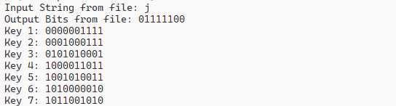OUTPUT

Practical 3

* + Implementation of Extended Euclidean Algorithm

ExtendedEuclidean.c

*#include* <stdio.h>

*int* t1 = 0, t2 = 1, q, r, t;

*int* extendedEuclidean(*int* a, *int* b)

{

*while* (b != 0)

    {

        q = a / b;

        r = a % b;

        t = t1 - t2 * q;

        t1 = t2;

        t2 = t;

        a = b;

        b = r;

    }

*return* a != 1 ? 0 : t1;

}

*int* main()

{

*int* a, b, result;

    printf("Inverse of: ");

    scanf("%d", &a);

    printf("With modulo: ");

    scanf("%d", &b);

    result = extendedEuclidean(b, a);

*if* (result == 0)

    {

        printf("Inverse does not exist\n");

*return* 0;

    }

*else* *if* (result < 0)

    {

        result += b;

    }

    printf("Inverse: %d\n", result);

*return* 0;

}

OUTPUT

Practical 4

* + Implementation of RSA with all required algorithms

rsa.c

*#include* <stdio.h>

*#include* <math.h>

*int* isPrime(*int* n)

{

*int* i;

*for* (i = 2; i < sqrt(n); i++)

    {

*if* (n % i == 0)

        {

*return* 0;

        }

    }

*return* 1;

}

*int* gcd(*int* a, *int* b)

{

*if* (b == 0)

    {

*return* a;

    }

*return* gcd(b, a % b);

}

*int* extendedEuclidean(*int* a, *int* b)

{

*int* t1 = 0, t2 = 1, q, r, t;

*while* (b != 0)

    {

        q = a / b;

        r = a % b;

        t = t1 - t2 * q;

        t1 = t2;

        t2 = t;

        a = b;

        b = r;

    }

*return* a != 1 ? 0 : t1;

}

*int* fastExponentiation(*int* a, *int* b, *int* n)

{

*int* bitCount = (*int*)ceil(log2(b)); *// Cast log2 result to int*

*int* aBinary[bitCount];

*int* modValues[bitCount];

*int* i;

*int* result = 1; *// Initialize result to 1*

*for* (i = bitCount - 1; i >= 0; i--)

    {

        aBinary[i] = b % 2;

        b = b / 2;

    }

*for* (i = bitCount - 1; i >= 0; i--)

    {

*if* (i == bitCount - 1) *// Change i == 0 to i == bitCount - 1*

        {

            modValues[i] = a % n;

        }

*else*

        {

            modValues[i] = (modValues[i + 1] * modValues[i + 1]) % n; *// Change i - 1 to i + 1*

        }

    }

*for* (i = 0; i < bitCount; i++)

    {

*if* (aBinary[i] == 1)

        {

            result = (result * modValues[i]) % n; *// Add modulo operation here*

        }

    }

*return* result;

}

*int* main()

{

*int* p, q, e, d, n, phi;

*int* m, c;

    printf("Enter the value of p: ");

    scanf("%d", &p);

*if* (isPrime(p) == 0)

    {

        printf("p is not prime\n");

*return* 0;

    }

    printf("Enter the value of q: ");

    scanf("%d", &q);

*if* (isPrime(q) == 0)

    {

        printf("q is not prime\n");

*return* 0;

    }

    n = p * q;

    phi = (p - 1) * (q - 1);

    printf("Enter the value of e between 1 and %d: ", phi);

    scanf("%d", &e);

*if* (e < 1 || e > phi)

    {

        printf("Invalid value of e\n");

*return* 0;

    }

*if* (gcd(e, phi) != 1)

    {

        printf("Invalid value of e\n");

*return* 0;

    }

    d = extendedEuclidean(phi, e);

*if* (d < 0)

    {

        d += phi;

    }

    printf("Public key: (%d, %d)\n", e, n);

    printf("Private key: (%d, %d)\n", d, n);

    printf("Enter the message: ");

    scanf("%d", &m);

    c = fastExponentiation(m, e, n);

    printf("Encrypted message: %d\n", c);

    m = fastExponentiation(c, d, n);

    printf("Decrypted message: %d\n", m);

*return* 0;

}

OUTPUT

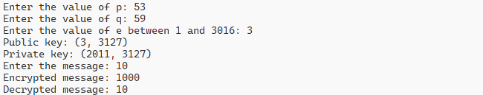

Practical 5

* + Demonstration of CCA2 attack on RSA

cca2.c

*// CCA2 attak on RSA*

*#include* <stdio.h>

*#include* <math.h>

*int* isPrime(*int* n)

{

*int* i;

*for* (i = 2; i < sqrt(n); i++)

    {

*if* (n % i == 0)

        {

*return* 0;

        }

    }

*return* 1;

}

*int* gcd(*int* a, *int* b)

{

*if* (b == 0)

    {

*return* a;

    }

*return* gcd(b, a % b);

}

*int* extendedEuclidean(*int* a, *int* b)

{

*int* t1 = 0, t2 = 1, q, r, t;

*while* (b != 0)

    {

        q = a / b;

        r = a % b;

        t = t1 - t2 * q;

        t1 = t2;

        t2 = t;

        a = b;

        b = r;

    }

*return* a != 1 ? 0 : t1;

}

*int* fastExponentiation(*int* a, *int* b, *int* n)

{

*int* bitCount = (*int*)ceil(log2(b)); *// Cast log2 result to int*

*int* aBinary[bitCount];

*int* modValues[bitCount];

*int* i;

*int* result = 1; *// Initialize result to 1*

*for* (i = bitCount - 1; i >= 0; i--)

    {

        aBinary[i] = b % 2;

        b = b / 2;

    }

*for* (i = bitCount - 1; i >= 0; i--)

    {

*if* (i == bitCount - 1) *// Change i == 0 to i == bitCount - 1*

        {

            modValues[i] = a % n;

        }

*else*

        {

            modValues[i] = (modValues[i + 1] * modValues[i + 1]) % n; *// Change i - 1 to i + 1*

        }

    }

*for* (i = 0; i < bitCount; i++)

    {

*if* (aBinary[i] == 1)

        {

            result = (result * modValues[i]) % n; *// Add modulo operation here*

        }

    }

*return* result;

}

*int* main()

{

*int* p, q, e, d, n, phi;

*int* m, c;

*int* m1, c1, decOfC1, mDec;

    printf("\n-----------------CHALLENGER WILL COMPUTE CIPHER TEXT-----------------\n\n");

*do*

    {

        printf("Enter the value of p: ");

        scanf("%d", &p);

    } *while* (!isPrime(p));

*do*

    {

        printf("Enter the value of q: ");

        scanf("%d", &q);

    } *while* (!isPrime(q));

    n = p * q;

    printf("\nValue of n: %d\n", n);

    phi = (p - 1) * (q - 1);

    printf("Value of phi: %d\n", phi);

*do*

    {

        printf("\nEnter the value of e between 1 and %d: ", phi);

        scanf("%d", &e);

    } *while* (e < 1 || e > phi || gcd(e, phi) != 1);

    d = extendedEuclidean(phi, e);

*if* (d < 0)

    {

        d += phi;

    }

    printf("Value of d: %d\n", d);

    printf("\nPublic key: (%d, %d)\n", e, n);

    printf("Private key: (%d, %d)\n", d, n);

    printf("\nEnter the message: ");

    scanf("%d", &m);

    c = fastExponentiation(m, e, n);

    printf("Encrypted message: %d\n", c);

    printf("\n\n-----------------CHALLENGER WILL GIVE %d TO ADVERSARY-----------------\n\n", c);

    printf("\n-----------------ADVERSARY WILL CHOOSE M1-----------------\n\n");

    printf("Enter the message: ");

    scanf("%d", &m1);

    printf("\n");

    printf("\n-----------------C1 = C*M1^e mod n-----------------\n\n");

    c1 = (c * fastExponentiation(m1, e, n)) % n;

    printf("Encrypted message: %d\n", c1);

    printf("\n\n-----------------ADVERSARY WILL QUERY DECRYPTION OF %d-----------------\n\n", c1);

    decOfC1 = fastExponentiation(c1, d, n);

    printf("Decrypted message: %d\n", decOfC1);

    printf("\n\n-----------------ADVERSARY COMPUTES M1 INVERSE WITH RESPECT TO N-----------------\n\n");

*int* m1Inverse = extendedEuclidean(n, m1);

*if* (m1Inverse < 0)

    {

        m1Inverse += n;

    }

    printf("M1 inverse: %d\n", m1Inverse);

    printf("\n\n-----------------ADVERSARY WILL COMPUTE M = C1*M1^-1 mod n-----------------\n\n");

    mDec = (decOfC1 * m1Inverse) % n;

    printf("Decrypted message: %d\n\n", mDec);

*if* (mDec == m)

    {

        printf("Adversary has successfully decrypted the message\n");

    }

*else*

    {

        printf("Adversary has failed to decrypt the message\n");

    }

*return* 0;

}

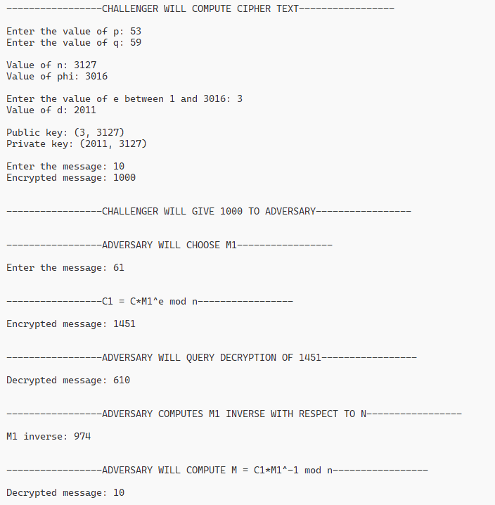OUTPUT

Practical 6

* + Implementation of Elgamal Algorithm for Encryption

elgamal.c

*#include* <stdio.h>

*#include* <math.h>

*int* fastExponentiation(*int* a, *int* b, *int* n)

{

*int* bitCount = (*int*)ceil(log2(b)); *// Cast log2 result to int*

*int* aBinary[bitCount];

*int* modValues[bitCount];

*int* i;

*int* result = 1; *// Initialize result to 1*

*for* (i = bitCount - 1; i >= 0; i--)

    {

        aBinary[i] = b % 2;

        b = b / 2;

    }

*for* (i = bitCount - 1; i >= 0; i--)

    {

*if* (i == bitCount - 1) *// Change i == 0 to i == bitCount - 1*

        {

            modValues[i] = a % n;

        }

*else*

        {

            modValues[i] = (modValues[i + 1] * modValues[i + 1]) % n; *// Change i - 1 to i + 1*

        }

    }

*for* (i = 0; i < bitCount; i++)

    {

*if* (aBinary[i] == 1)

        {

            result = (result * modValues[i]) % n; *// Add modulo operation here*

        }

    }

*return* result;

}

*void* main()

{

*int* p, g, x, y;

*int* m, r, c1, c2, dec_m;

    printf("Enter the value of p: ");

    scanf("%d", &p);

    printf("Enter the value of g: ");

    scanf("%d", &g);

    printf("\nEnter the private key x such that 1 < x < p-1: ");

    scanf("%d", &x);

    y = (*int*)pow(g, x) % p;

    printf("\nThe public key is: %d %d %d \n", p, g, y);

    printf("The private key is: %d %d %d \n", p, g, x);

    printf("\nEnter the message m: ");

    scanf("%d", &m);

    printf("\nEnter random number r such that 1 < r < p-1: ");

    scanf("%d", &r);

    c1 = fastExponentiation(g, r, p);

    c2 = fastExponentiation(y, r, p) * m % p;

    printf("\nThe cipher text is: %d %d \n", c1, c2);

    dec_m = c2 * fastExponentiation(c1, p - 1 - x, p) % p;

    printf("\nThe decrypted message is: %d \n", dec_m);

}

OUTPUT

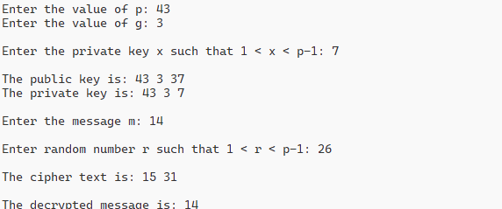

Practical 7

* + Implementation of Elgamal Algorithm for Digital Signature

Elgamal_digital_sign.c

*#include* <stdio.h>

*#include* <math.h>

*int* fastExponentiation(*int* a, *int* b, *int* n)

{

*int* result = 1;

    a = a % n;

*while* (b > 0)

    {

*if* (b % 2 == 1)

        {

            result = (result * a) % n;

        }

        b = b / 2;

        a = (a * a) % n;

    }

*return* result;

}

*int* gcd(*int* a, *int* b)

{

*if* (b == 0)

    {

*return* a;

    }

*return* gcd(b, a % b);

}

*int* hashFunction(*int* m, *int* p)

{

*return* m * m % (p - 1);

}

*int* randomK(*int* p)

{

*for* (*int* i = 2; i < p - 1; i++)

    {

*if* (gcd(i, p - 1) == 1)

        {

*return* i;

        }

    }

}

*int* inverse(*int* a, *int* b)

{

*for* (*int* i = 1; i < b; i++)

    {

*if* ((a * i) % b == 1)

        {

*return* i;

        }

    }

}

*void* main()

{

*int* p, g, x, y;

*int* m, hash, k, s1, s2, kInv;

*int* v1, v2;

    printf("-----------------SENDER SIDE-----------------\n\n");

    printf("Enter the value of p: ");

    scanf("%d", &p);

    printf("Enter the value of g: ");

    scanf("%d", &g);

    printf("\nEnter the private key x such that 1 < x < p-1: ");

    scanf("%d", &x);

    y = fastExponentiation(g, x, p);

    printf("\nThe public key is: %d %d %d \n", p, g, y);

    printf("The private key is: %d %d %d \n", p, g, x);

    printf("\nEnter the message m: ");

    scanf("%d", &m);

*// hash = hashFunction(m, p);*

    hash = m;

    k = randomK(p);

    printf("The hash value is: %d\n", hash);

    printf("The random number k is: %d\n", k);

    kInv = inverse(k, p - 1);

    printf("The inverse of k is: %d\n", kInv);

    s1 = fastExponentiation(g, k, p);

    s2 = kInv * (hash - x * s1) % (p - 1);

    printf("The signature is: %d %d\n", s1, s2);

    printf("\n\n-----------------RECEIVER SIDE-----------------\n\n");

    v1 = fastExponentiation(g, hash, p);

    v2 = (fastExponentiation(y, s1, p) * fastExponentiation(s1, s2, p)) % p;

    printf("v1: %d\n", v1);

    printf("v2: %d\n", v2);

*if* (v1 == v2)

    {

        printf("The signature is verified\n");

    }

*else*

    {

        printf("The signature is not verified\n");

    }

}

OUTPUT

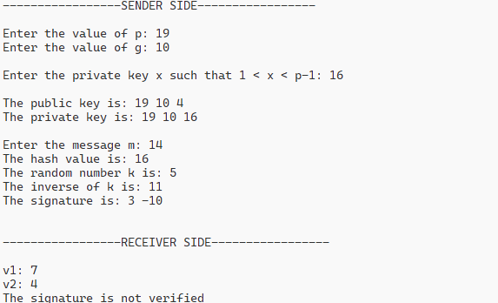

Practical 8

* + Implementation of your own designed pseudorandom number generation

random.c

*#include* <stdio.h>

*#include* <stdlib.h>

*#include* <time.h>

*unsigned* *long* *long* *int* custom_rand(*unsigned* *long* *long* *int* seed)

{

*unsigned* *long* *long* *int* multiplier = 6364136223846793005ULL;

*unsigned* *long* *long* *int* increment = 1442695040888963407ULL;

*unsigned* *long* *long* *int* modulus = 18446744073709551615ULL; *// 2^64 - 1 (64-bit unsigned integer max value)*

*// Calculate the next pseudo-random number using LCG algorithm*

    seed = (multiplier * seed + increment) % modulus;

*return* seed;

}

*int* main()

{

*unsigned* *long* *long* *int* seed = 12345; *// Initial seed value*

*int* i;

*int* range_min = 0;

*int* range_max = 100;

*// Use current time as seed for better randomness*

*time_t* t;

    time(&t);

    seed = t;

*// Generate and print 10 pseudo-random numbers within the specified range*

*for* (i = 0; i < 10; i++)

    {

*// Generate next pseudo-random number*

        seed = custom_rand(seed);

*// map to the specified range*

        printf("%d\n", range_min + (seed % (range_max - range_min + 1)));

    }

*return* 0;

}

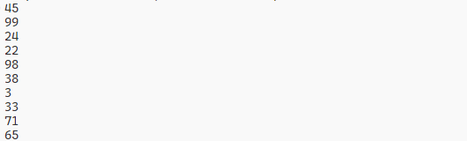OUTPUT

Practical 9

* + Implement Shamir secret sharing scheme

shamir.c

*#include* <stdio.h>

*#include* <stdlib.h>

*#include* <time.h>

*#include* <math.h>

*int* random_number(*long* x, *long* a, *long* c, *int* m)

{

*// Calculate the next pseudo-random number using Linear Congruential Generator (LCG) algorithm*

*long* result = (x * a + c) % m;

*int* res = (*int*)result;

*return* res;

}

*int* main()

{

*int* S, n, k;

    printf("Enter Secret (S): ");

    scanf("%d", &S);

    printf("Enter Number Of Partitions(n): ");

    scanf("%d", &n);

    printf("Enter number of points(k): ");

    scanf("%d", &k);

*// Generate a random polynomial of degree (k-1) with coefficients from LCG algorithm*

*int* polynomial[k];

    polynomial[0] = S;

*for* (*int* i = 1; i < k; i++)

    {

        polynomial[i] = random_number(time(0), 17, time(0) + 3, 967);

    }

*// Generate random points on the polynomial*

*int* points[n][2];

*for* (*int* i = 1; i < n + 1; i++)

    {

        points[i - 1][0] = i;

*int* sum = 0;

*for* (*int* j = 0; j < k; j++)

        {

            sum += pow(points[i - 1][0], j) * polynomial[j];

        }

        points[i - 1][1] = sum;

    }

*// Copy random points for Lagrange interpolation*

*int* random_points[k][2];

*for* (*int* i = 0; i < k; i++)

    {

        random_points[i][0] = points[i][0];

        random_points[i][1] = points[i][1];

    }

*// Lagrange Interpolation (for finding S, the term without any polynomial)*

*double* l[k];

*int* found_Secret = 0;

*for* (*int* i = 0; i < k; i++)

    {

        l[i] = 1.0;

*for* (*int* j = 0; j < k; j++)

        {

*if* (j != i)

            {

*// Calculate the Lagrange interpolation coefficients*

                l[i] *= (*double*)-1 * (random_points[j][0]) / (random_points[i][0] - random_points[j][0]);

            }

        }

*// Calculate the secret by summing up the Lagrange coefficients multiplied by the y-values of the points*

        found_Secret += (*int*)(l[i]) * random_points[i][1];

    }

    printf("\nSecret Found: %d\n", found_Secret);

*return* 0;

}

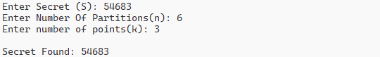OUTPUT

Practical 10

* + Implementation of SHA 256 algorithm

Sha256.c

*#include* <stdio.h>

*#include* <stdint.h>

*#include* <string.h>

*// Rotate bits to the right*

*#define* ROTR(x, n) (((x) >> (n)) | ((x) << (32 - (n))))

*// SHA-256 Constants*

*const* *uint32_t* K[64] = {

    0x428a2f98, 0x71374491, 0xb5c0fbcf, 0xe9b5dba5,

    0x3956c25b, 0x59f111f1, 0x923f82a4, 0xab1c5ed5,

    0xd807aa98, 0x12835b01, 0x243185be, 0x550c7dc3,

    0x72be5d74, 0x80deb1fe, 0x9bdc06a7, 0xc19bf174,

    0xe49b69c1, 0xefbe4786, 0x0fc19dc6, 0x240ca1cc,

    0x2de92c6f, 0x4a7484aa, 0x5cb0a9dc, 0x76f988da,

    0x983e5152, 0xa831c66d, 0xb00327c8, 0xbf597fc7,

    0xc6e00bf3, 0xd5a79147, 0x06ca6351, 0x14292967,

    0x27b70a85, 0x2e1b2138, 0x4d2c6dfc, 0x53380d13,

    0x650a7354, 0x766a0abb, 0x81c2c92e, 0x92722c85,

    0xa2bfe8a1, 0xa81a664b, 0xc24b8b70, 0xc76c51a3,

    0xd192e819, 0xd6990624, 0xf40e3585, 0x106aa070,

    0x19a4c116, 0x1e376c08, 0x2748774c, 0x34b0bcb5,

    0x391c0cb3, 0x4ed8aa4a, 0x5b9cca4f, 0x682e6ff3,

    0x748f82ee, 0x78a5636f, 0x84c87814, 0x8cc70208,

    0x90befffa, 0xa4506ceb, 0xbef9a3f7, 0xc67178f2};

*// SHA-256 initial hash values*

*const* *uint32_t* initial_hash[8] = {

    0x6a09e667, 0xbb67ae85, 0x3c6ef372, 0xa54ff53a,

    0x510e527f, 0x9b05688c, 0x1f83d9ab, 0x5be0cd19};

*// SHA-256 Functions*

*#define* CH(x, y, z) (((x) & (y)) ^ (~(x) & (z)))

*#define* MAJ(x, y, z) (((x) & (y)) ^ ((x) & (z)) ^ ((y) & (z)))

*#define* EP0(x) (ROTR(x, 2) ^ ROTR(x, 13) ^ ROTR(x, 22))

*#define* EP1(x) (ROTR(x, 6) ^ ROTR(x, 11) ^ ROTR(x, 25))

*#define* SIG0(x) (ROTR(x, 7) ^ ROTR(x, 18) ^ ((x) >> 3))

*#define* SIG1(x) (ROTR(x, 17) ^ ROTR(x, 19) ^ ((x) >> 10))

*// SHA-256 Compression Function*

*void* sha256_compress(*uint32_t* state[8], *const* *uint8_t* block[64])

{

*uint32_t* W[64];

*uint32_t* a, b, c, d, e, f, g, h;

*uint32_t* T1, T2;

*// Prepare message schedule*

*for* (*int* t = 0; t < 16; ++t)

    {

        W[t] = (block[t * 4] << 24) | (block[t * 4 + 1] << 16) | (block[t * 4 + 2] << 8) | block[t * 4 + 3];

    }

*for* (*int* t = 16; t < 64; ++t)

    {

        W[t] = SIG1(W[t - 2]) + W[t - 7] + SIG0(W[t - 15]) + W[t - 16];

    }

*// Initialize working variables*

    a = state[0];

    b = state[1];

    c = state[2];

    d = state[3];

    e = state[4];

    f = state[5];

    g = state[6];

    h = state[7];

*// Compression loop*

*for* (*int* t = 0; t < 64; ++t)

    {

        T1 = h + EP1(e) + CH(e, f, g) + K[t] + W[t];

        T2 = EP0(a) + MAJ(a, b, c);

        h = g;

        g = f;

        f = e;

        e = d + T1;

        d = c;

        c = b;

        b = a;

        a = T1 + T2;

    }

*// Update hash state*

    state[0] += a;

    state[1] += b;

    state[2] += c;

    state[3] += d;

    state[4] += e;

    state[5] += f;

    state[6] += g;

    state[7] += h;

}

*// SHA-256 hash function*

*void* sha256(*const* *uint8_t* *message, *size_t* len, *uint8_t* hash[32])

{

*uint32_t* state[8];

*uint32_t* length_bits = len * 8;

*uint8_t* block[64];

*size_t* i;

*// Initialize hash state*

*for* (i = 0; i < 8; ++i)

    {

        state[i] = initial_hash[i];

    }

*// Process message in 512-bit blocks*

*while* (len >= 64)

    {

        memcpy(block, message, 64);

        sha256_compress(state, block);

        message += 64;

        len -= 64;

    }

*// Append padding and length*

    memset(block, 0, 64);

    memcpy(block, message, len);

    block[len] = 0x80;

*if* (len < 56)

    {

*// There is enough room for padding and length in this block*

*for* (i = 0; i < 8; ++i)

        {

            block[56 + i] = (length_bits >> (56 - i * 8)) & 0xFF;

        }

        sha256_compress(state, block);

    }

*else*

    {

*// We need an additional block to store padding and length*

        sha256_compress(state, block);

        memset(block, 0, 64);

*for* (i = 0; i < 8; ++i)

        {

            block[56 + i] = (length_bits >> (56 - i * 8)) & 0xFF;

        }

        sha256_compress(state, block);

    }

*// Write final hash*

*for* (i = 0; i < 8; ++i)

    {

        hash[i * 4] = (state[i] >> 24) & 0xFF;

        hash[i * 4 + 1] = (state[i] >> 16) & 0xFF;

        hash[i * 4 + 2] = (state[i] >> 8) & 0xFF;

        hash[i * 4 + 3] = state[i] & 0xFF;

    }

}

*// Utility function to print hash in hexadecimal format*

*void* print_hash(*const* *uint8_t* hash[32])

{

*for* (*int* i = 0; i < 32; ++i)

    {

        printf("%02x", hash[i]);

    }

    printf("\n");

}

*int* main()

{

*const* *char* *message = "Hello, world!";

*uint8_t* hash[32];

    sha256((*uint8_t* *)message, strlen(message), hash);

    printf("SHA-256 hash of '%s':\n", message);

    print_hash(hash);

*return* 0;

}

OUTPUT

Practical 11

* + Implementation of PBC library and performing Bilinear pairing operation

Steps:

1. Install m4, flex and bison using below commands
   * 1. sudo apt-get install m4
     2. sudo apt-get install flex
     3. sudo apt-get install bison
2. Download gmp and install it using below commands
   * 1. configure
     2. make
     3. sudo make install
3. After installing gmp, go to https://crypto.stanford.edu/pbc/download.html and download pbc-0.5.14.tar.gz
4. Then go to pcb-0.5.14 folder and open the terminal in that folder
5. For performing bilinear pairing follow below commands
   * 1. configure
     2. make
     3. sudo make install
     4. sudoldconfig
     5. 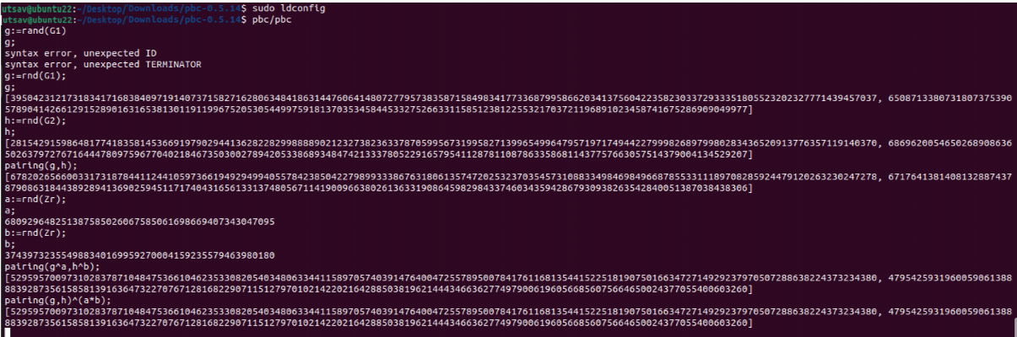pbc/pbc
6. Now for bilinear pairing go to location pcb-0.5.14/example and open terminal in that folder then write below commands
   * 1. gcc -o test bls.c -L. -lgmp -lpbc
     2. ./test <~/Download/pbc-0.5.14/param/a.param

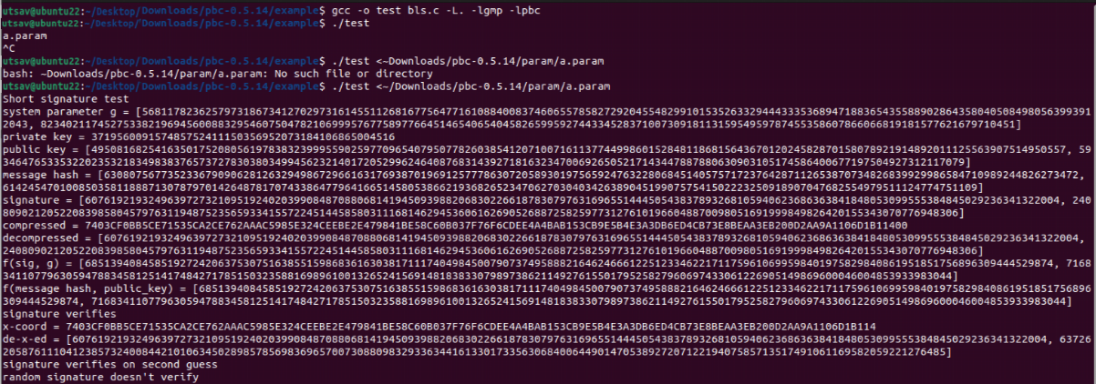

* CODE:

*#include* <pbc/pbc.h>

*#include* <pbc/pbc_test.h>

*int* main(*int* argc, *char* **argv)

{

    pairing_t pairing;

    element_t g, h;

    element_t public_key, sig;

    element_t secret_key;

    element_t temp1, temp2;

    pbc_demo_pairing_init(pairing, argc, argv);

    element_init_G2(g, pairing);

    element_init_G2(public_key, pairing);

    element_init_G1(h, pairing);

    element_init_G1(sig, pairing);

    element_init_GT(temp1, pairing);

    element_init_GT(temp2, pairing);

    element_init_Zr(secret_key, pairing);

    printf("Short signature test\n");

*// generate system parameters*

    element_random(g);

    element_printf("system parameter g = %B\n", g);

*// generate private key*

    element_random(secret_key);

    element_printf("private key = %B\n", secret_key);

*// compute corresponding public key*

    element_pow_zn(public_key, g, secret_key);

    element_printf("public key = %B\n", public_key);

*// generate element from a hash*

*// for toy pairings, should check that pairing(g, h) != 1*

    element_from_hash(h, "hashofmessage", 13);

    element_printf("message hash = %B\n", h); *// h^secret_key is the signature // in real life: only output the first coordinate*

    element_pow_zn(sig, h, secret_key);

    element_printf("signature = %B\n", sig);

    {

*int* n = pairing_length_in_bytes_compressed_G1(pairing);

*// int n = element_length_in_bytes_compressed(sig);*

*int* i;

*unsigned* *char* *data = pbc_malloc(n);

        element_to_bytes_compressed(data, sig);

        printf("compressed = ");

*for* (i = 0; i < n; i++)

        {

            printf("%02X", data[i]);

        }

        printf("\n");

        element_from_bytes_compressed(sig, data);

        element_printf("decompressed = %B\n", sig);

        pbc_free(data);

    }

*// Verification part 1*

    element_pairing(temp1, sig, g);

    element_printf("f(sig, g) = %B\n", temp1);

*// Verification part 2*

*// should match above*

    element_pairing(temp2, h, public_key);

    element_printf("f(message hash, public_key) = %B\n", temp2);

*if* (!element_cmp(temp1, temp2))

    {

*// Signature is valid*

    }

    {

        printf("signature verifies\n");

    }

*else*

    {

        printf("*BUG* signature does not verify *BUG*\n");

    }

    {

*int* n = pairing_length_in_bytes_x_only_G1(pairing);

*// int n = element_length_in_bytes_x_only(sig);*

*int* i;

*unsigned* *char* *data = pbc_malloc(n);

        element_to_bytes_x_only(data, sig);

        printf("x-coord = ");

*for* (i = 0; i < n; i++)

        {

            printf("%02X", data[i]);

        }

        printf("\n");

        element_from_bytes_x_only(sig, data);

        element_printf("de-x-ed = %B\n", sig);

        element_pairing(temp1, sig, g);

*if* (!element_cmp(temp1, temp2))

        {

            printf("signature verifies on first guess\n");

        }

*else*

        {

            element_invert(temp1, temp1);

*if* (!element_cmp(temp1, temp2))

            {

                printf("signature verifies on second guess\n");

            }

*else*

            {

                printf("*BUG* signature does not verify *BUG*\n");

            }

        }

        pbc_free(data);

    }

*// a random signature shouldn't verify*

    element_random(sig);

    element_pairing(temp1, sig, g);

*if* (element_cmp(temp1, temp2))

    {

        printf("random signature doesn't verify\n");

    }

*else*

    {

        printf("*BUG* random signature verifies *BUG*\n");

    }

    element_clear(sig);

    element_clear(public_key);

    element_clear(secret_key);

    element_clear(g);

    element_clear(h);

    element_clear(temp1);

    element_clear(temp2);

    pairing_clear(pairing);

*return* 0;

}

Practical 12

* + Use Wireshark tool to view the network traffic passing across your lab computers

# Wireshark:

Wireshark functions as a network protocol analyzer, capturing packets from various network connections such as those between your computer and your home office or the internet. In the context of a typical Ethernet network, a packet refers to a discrete unit of data. Wireshark stands as the most commonly utilized packet sniffer globally. Like its counterparts, Wireshark performs three primary tasks:

1. Packet Capture: Wireshark actively listens to network connections in real-time, capturing entire streams of traffic which may encompass tens of thousands of packets simultaneously.
2. Filtering: Utilizing filters, Wireshark effectively sifts through the abundance of live data, enabling users to isolate specific information of interest.
3. Visualization: Wireshark not only permits users to delve into individual network packets but also facilitates the visualization of entire conversations and network streams, offering a comprehensive understanding of network activities.

**What are the Applications of Wireshark?**

Wireshark serves various purposes, one of which is troubleshooting networks experiencing performance issues. Cybersecurity experts frequently employ Wireshark to track connections, inspect the contents of suspicious network transactions, and detect spikes in network traffic. It constitutes a significant component of any IT professional's arsenal – provided the professional possesses the requisite expertise to utilize it effectively.

**Interpreting Color Codes in Wireshark:**

Once packets are captured, understanding their significance becomes paramount. Wireshark simplifies this task by employing intuitive color coding to denote different packet types. The following table delineates the default colors assigned to major packet categories.

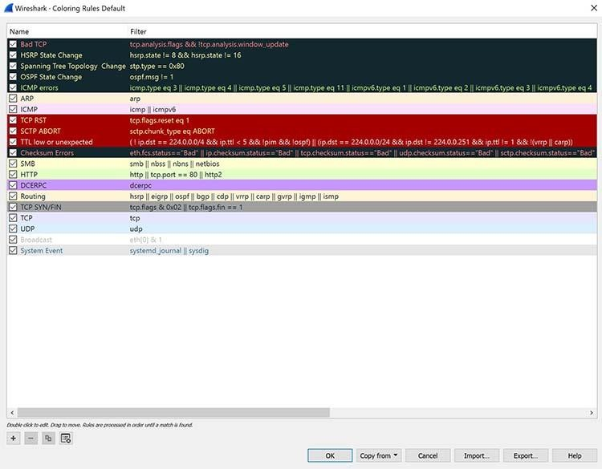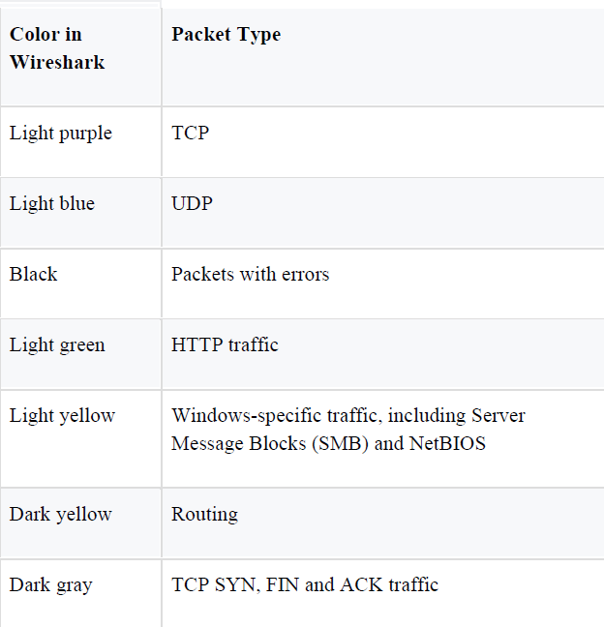

**When to Utilize Wireshark?**

Wireshark serves as a reliable tool embraced by a spectrum of entities including government agencies, educational institutions, corporations, small businesses, and nonprofits for diagnosing network issues. Moreover, Wireshark doubles as an educational resource.

Novices in the realm of information security can leverage Wireshark to grasp concepts such as network traffic analysis, the dynamics of communication in the presence of specific protocols, and the identification of anomalies during troubleshooting.

However, Wireshark has its limitations. Firstly, it proves ineffective for users lacking a fundamental understanding of network protocols. Regardless of its utility, no tool can adequately substitute for comprehensive knowledge. Consequently, proficient usage of Wireshark mandates a deep comprehension of network operations, encompassing elements like the three-way TCP handshake and various protocols such as TCP, UDP, DHCP, and ICMP.

Secondly, under standard circumstances, Wireshark fails to capture traffic from all network systems. In modern network infrastructures employing switches, Wireshark, like other conventional packet-capturing tools, can only intercept traffic between the local computer and the remote system it engages with.

Thirdly, while Wireshark can detect malformed packets and implement color coding, it lacks actual alert functionalities, thus distinguishing itself from an intrusion detection system (IDS).

Fourthly, Wireshark proves ineffectual in decrypting encrypted traffic.

Lastly, Wireshark faces challenges in discerning the authenticity of IPv4 packets, particularly concerning the potential for spoofing. Differentiating between genuine and fabricated IP addresses necessitates a higher level of expertise from IT professionals and potentially supplementary software tools

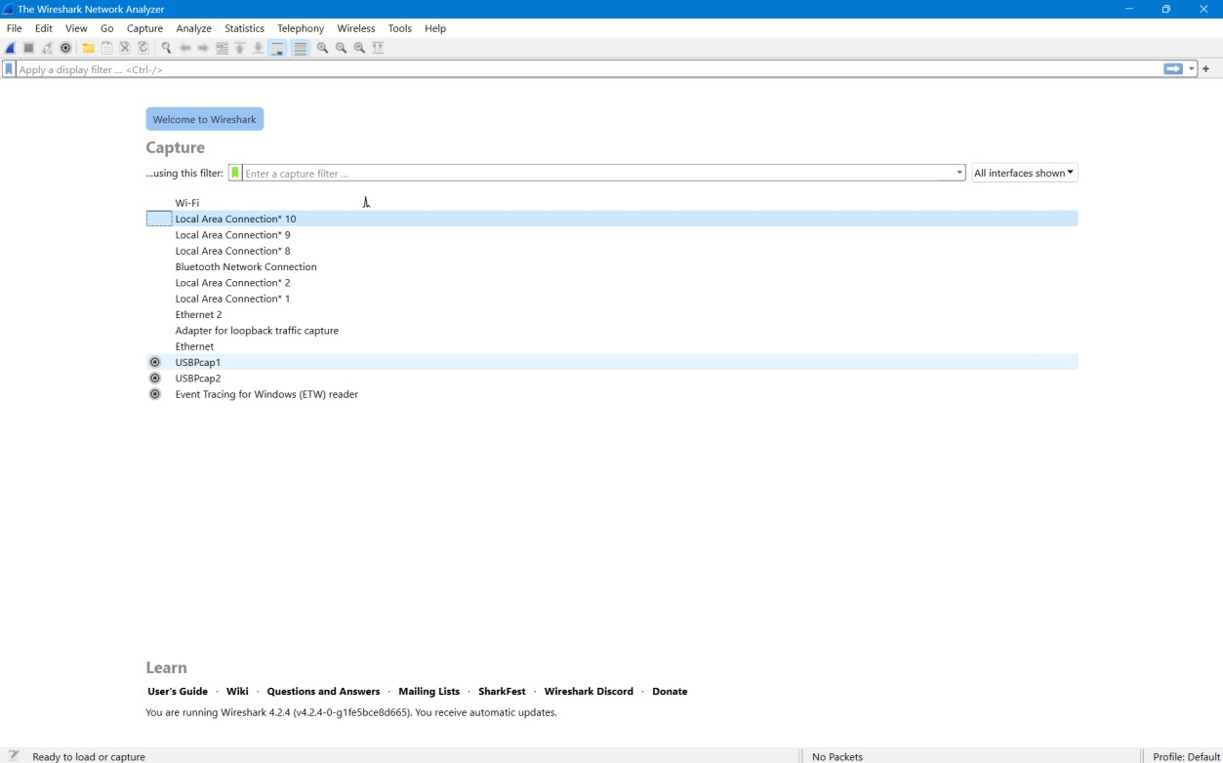EXAMPLE:

